

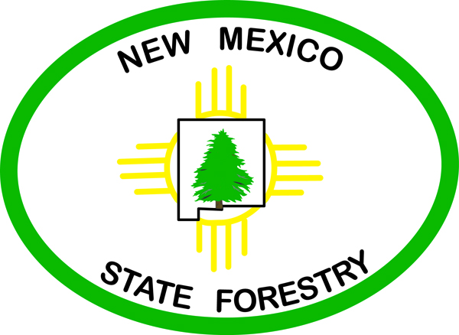
Bill Richardson

Governor

Joanna Prukop Arthur “Butch” Blazer

Cabinet Secretary Division Director
Reese Fullerton Forestry Division

Deputy Cabinet Secretary

Web-site Links for New Mexico’s Communities

Provided by the Urban and Community Forestry Program

New Mexico's Water Conservation Program “An excellent resource for wise use of your water”

Maximize your community green spaces through design and funding opportunities for clean air and clean water
EPA's Green Infrastructure Program
EPA Heat Island Resources

Human Dimensions of Urban Forestry “An excellent resource on human benefits gained from trees in your community”

US Forest Service links on trees and environmental tools –
http://www.fs.fed.us/ne/syracuse/index.html

US Forest Service Center for Urban Forest Research at UC Davis -- http://www.fs.fed.us/psw/programs/cufr/

