Greater Rio Grande Watershed Alliance Project Proposal Template

- All proposals are due to the GRGWA Technical Committee by June 30, 2012. Only proposals turned in by this date will be considered for 2012 funding.

- GRGWA Technical Committee members (Mike Matush, Susan Rich, Terrell Treat, Jim Wanstall, Jill Wick, and Joe Zebrowski) are available to assist with proposal development.

Project name: Valencia Bosque Habitat Recovery-Revegetation Project 2012-13 (Priority 2)

Project type(s): Re-vegetation

Project proponent: Valencia Soil & Water Conservation District

Project location: multiple pre-existing project sites within Belen to Los Lunas reach of VSWCD projects within the Middle Rio Grande riparian corridor along the east side of the river in Belen and Tome and on the west side of the river at the bridge in Los Lunas, New Mexico. Maps attached are the NM Forestry mapping for retreatment in the previous funding cycle for these project areas.
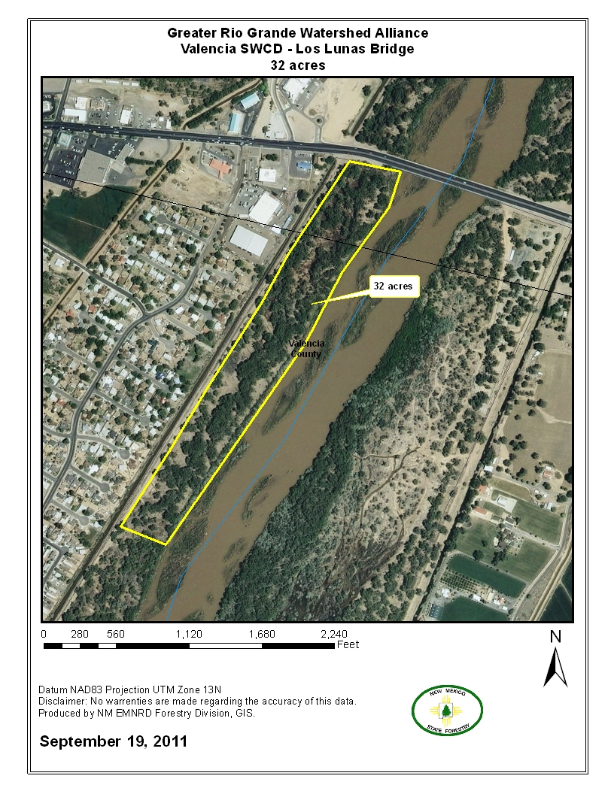
Maps attached here include the sites for pre-existing project sites for revegetation in this proposal; Tome Site, Belen Sites 1-5 for revegetation on Belen Sites 3 & 5 only and the Los Lunas Bridge site

Landowner(s): The Middle Rio Grande Conservancy District Planner, Yasmeen Najmi, previously visited Belen and the Tome project sites with the District (Charlie Sanchez, Madeline Miller), Jim Wanstall for the GRGWA Technical Committee for project scopes that originally included this revegetation phase of site rehabilitation and habitat recovery. Originally the Los Lunas site was approved for grass seeding an a more open firebreak site at the Los Lunas Bridge and VSWCD will need to review the amount of understory shrubs and floor canopy to put into this site.

How is this site accessed? As with the other proposals, these project areas within gated MRGCD properties are accessible by permitted key. The District has keys and loaners can be arranged for contractors as needed. Also, the NM Forestry IWC has keys if they cooperate on this project.

Project objective(s): To progress in these treated areas to establishing native dominant habitat by re-vegetation with native understory and floor plantings. Ability of native plantings to dominate over invasives in the project areas will be assessed following plantings. Limiting vehicle access in these areas during this re-vegetation phase needs to be incorporated into preparation for planting shrubs and grasses as needed; some sites are frequented by vehicle, others not. Where recreational access is expected some placing of snags may help protect plantings and define where vehicles can go.

Size of project: This project includes three areas for re-vegetation the Belen to Los Lunas reach of the Middle Rio Grande riparian corridor; The Belen Sites 3 & 5 cover 40 acres, the Tome Site covers 26.8 acres and the Los Lunas Site covers 32 acres for a total project area of 98.8 acres.

Current site description: Riparian ecosystem; Middle Rio Grande Bosque. The pre-control habitat of this area was Rio Grande Cottonwood Bosque with decadent invasives salt cedar exotic dominant. Dead and down loading of older exotics stands was significant and a serious fire hazard in this heavily populated and accessed portion of the Bosque. The Marcel Reynolds Uncleared BEMP monitoring plots are within this site with some in the uncleared buffer area of 100 feet on south border of this site and the remaining plots to be monitored as ‘cleared’ following Phase 1 control of Salt Cedar (data of area uncleared since 2004 through the BEMP monitoring program). This site of clearing is also adjacent to and west of the Whitfield Wildlife Conservation Area, and visible to visitors to the area. BEMP long term monitoring includes data on understory cover, surface fuels, depth to water table (and ultimately groundwater connectivity to the river) . Additionally helpful as baseline and post treatment site data as appropriate for planning would be tree densities, soil salinity, soil texture, crown base height (CBH) and overstory canopy cover.

Project site climate conditions for this southern portion of the Middle Rio Grande watershed include average winter temperatures of 32 degrees F( 0 degrees C) and to more than 100 degrees F (37 degrees C) in the summer. The frost free period is from June through September (120 days). Precipitation is < 8 inches (10 cm) per year generally with continued drought conditions in recent years. The majority of precipitation, 70-80% falls in the summer as ‘monsoonal’ thunderstorms with moisture derived from the Gulf of Mexico or Gulf of California. The winter precipitation comes in the form of snow and frontal rainstorms. Natural processes indicate generally that summer storms can contribute significantly to late summer and fall discharges, but peak runoff usually occurs in late spring (May – June) due to snowmelt (Anderholm, Radell, and Ritchey 1995)¹ but this irrigated river system is largely influenced by regulated flows from Cochiti Dam.

Generally, hydrology for the area shows variable connectivity of groundwater to river flow. Most areas have a shallow water table; within 2 to 6 feet of the surface. The Belen Bosque Restoration sites here just north of Reinken Road on the east side of the Middle Rio Grande through to this site, Whitfield West Phase 2, have been monitored monthly by Biologists and students through the Bosque Ecological Monitoring Program since fall of 2004. The data is regularly compiled into reports and useful for adaptive management consideration within the 150 acres of Belen Bosque Restoration sites for this plan. BEMP monitoring indicates that this site’s groundwater flow is connected to river flow.

Currently, plant communities include native and altered (salt cedar and Russian olive invasive dominant) riparian and grassland shrub communities of the Middle Rio Grande Bosque (riparian) corridor. Wildlife species of interest for the bosque sites within our District include the SW Willow Flycatcher, Yellow Billed Cuckoo, and the Rio Grande Wild Turkey.

The wildlife habitat of the Middle Rio Grande is recognized as a major migratory flyway as well as host to resident wildlife in the Bosque. There are some designated SW Willow Flycatcher stopover sites within the Bosque areas of Valencia County. This and the other VSWCD project sites are not specifically noted by MRGCD or the USFWS for significant nesting sites but restoration of the Bosque to native plant communities will support increased use by migratory birds and a more diverse and abundant resident wildlife population. Also, overall health of the watershed would be improved by a more diverse understory of native shrubs, grasses and forbes. For post treatment wildlife shelter, VSWCD utilizes snags and woodpiles whenever possible. The MRGCD allowance for snags is 3 per acre. While woodpiles are best mid size (ex. 10’ diameter and 5-6’ height - this size is not appropriate for areas within this plan due to fire concerns of wui areas) thus smaller piles, 3-4 per acre (see Appendix 2) for identified more open treated areas where the understory has not yet been re-established adequately will be utilized and more ‘living’ piles could be built. Thus far identified depredation concerns have been beaver damage of cottonwood poles and increased recreational use following clearing and control of invasives in Middle Rio Grande Bosque sites. To prevent beaver damage, tree guards have been used successfully in areas closer to river’s edge to prohibit damage to young pole plantings. This proposal includes revegetation of the mid-story and understory canopies only and possibly some mitigation of recreation access through placement of snags and placement of revegetation plantings such that they are not in paths of desired driven access.

Soils and their condition within the Middle Rio Grande floodplain generally speaking are as follows: predominant mixed alluvial land fluvaquents, riverwash, Brazito Sandy Clay Loam, and Pajarito Loamy Fine Sand (reference NRCS Soils surveys). Riverwash (Rw) and mixed alluvial land-fluvaquents predominant on most sites. Also the extent of salt loading in some areas from Salt cedar stands needs to be addressed more carefully for successful restoration of native plant communities. This site initially was very dense with dead and down and a dense overstory canopy thus site specific soil determinations need to be done for species selection in revegetation for native plant communities.

If this is a re-treatment or re-vegetation project, describe work that has been done previously and when it was completed: These sites have had multiple invasive control and retreatment events; the Belen sites from 2004 to 2012 have had initial control and three re-treatments of woody invasives, the Tome Site from 2008 to 2012 has had initial control of salt cedar and Russian olive and two re-treatments, and the Los Lunas Site from 2007 to 2012 has had initial control, and two re-treatments of invasives.

Desired site condition (Describe the site following treatment. Include potential re-vegetation, both natural and planted): Cottonwood upper story canopy as it exists on site at time of re-vegetation along with natural and planted native understory shrubs will dominate the landscape for wildlife habitat. The plantings will establish in a patchy mosaic around existing natural recruitments to ensure enough open upper story canopy for light to the understory of native shrubs, grasses and forbes. Wildlife species of interest for these sites include the SW Willow Flycatcher, Yellow Billed Cuckoo, and the Rio Grande Wild Turkey along with all resident wildlife of the area. Where coyote willow is present re-vegetation management should include ensuring limited vehicle access where coyote willow can thrive. Adding the following understory shrubs and midstory canopy as follows should establish a native dominant habitat;

- 300 shrubs for Tome site will be the most drought tolerant natives of this re-vegetation effort; four wing saltbush, Stretchberry, and sumac will be planted and the mostly intermediate aged existing Cottonwood canopy will remain mostly open for a more sparse and open habitat that extends the Rio Grande Turkey habitat project (Middle Rio Grande Chapter of the National Wild Turkey Federation)just north of the area. Placement of snags for protection of planted understory should also help grass cover to spread naturally where some cover already present and if possible to limit vehicle access on the site to allow the spread of floor cover over time.

- On Los Lunas Site, 15 acres from bridge maintained as firebreak as much as possible with grass cover and 400 native shrubs in clusters minimally planted in firebreak area and more so in south 17 acres of site for wildlife habitat and forage. Existing Cottonwood canopy allows good enough light for healthy understory growth in the following ratio of preferred native understory and mid canopy species; 50% Golden currant, 20% wolfberry, 20% NM Olive (Stretchberry), and 10% black willow trees (following assessment of soil salinity).

- Belen sites 3 & 5 will have existing intermediate aged forest of Cottonwoods and Black willow, planted native shrubs for wildlife forage and habitat, snags placed to protect understory of existing coyote willow groves and planted native shrubs to create habitat suitable for migratory and resident wildlife in the following ratio of preferred species; 50% Golden currant, 20% wolfberry, 20% NM Olive (Stretchberry), and 10% black willow trees (following assessment of soil salinity).

Justification: Re-vegetation to establish a native dominant understory and floor cover is the necessary next management step in minimizing invasive weed (re-sprout woody invasives and successional invasive weeds such as perennial pepperweed, kochia) spread in these sites, and for native habitat recovery for wildlife for resident and migratory wildlife. These sites are within the densely populated Middle Rio Grande Valley where much restoration work has been significant all along the east and west bosque corridors since 2002 for fire fuels reduction in protecting the area communities from crown fires. Being adjacent to wildland urban interface private residential, and agricultural lands along the Rio Grande which ultimately will benefit from long term reduction in fire fuels through native dominant habitat as well as mitigating spread of invasives into these private lands.

Is this project adjacent or near previous restoration projects?
The sites of re-vegetation for this proposal are part of previous projects as well as near or adjacent to previous sites of revegetation; The Belen Sites 3&5 are within Belen Sites 1-4 where Sites 1 and 3 have had re-vegetation of Cottonwoods, Black willows and understory shrubs. Sites 3 & 5 will benefit from additional re-vegetation measures following re-treatments in 2012. Belen Site 3 also is adjacent (north) to the Whitfield West Phase 2 sight. The Tome Site is not directly adjacent to VSWCD restoration sites but is adjacent (just south) to the Rio Grande Turkey Habitat Restoration Project.

Is there any baseline data (vegetation, ground water monitoring, etc.) available for this site? There is

BEMP monitoring of hydrology, floor cover, arthropods, dead & down litter has been ongoing since 2004 and continues in the Belen Site 1 & 2 which may be applicable to Belen Site 3 in part. There has been photopoint journaling carried out for these sites by the Forest and Watershed Health Institute for re-treaments conducted in 2012 and this would serve as some baseline data for this re-vegetation project.

How and by whom will the project be maintained? The Valencia Soil & Water Conservation District in cooperation with the Middle Rio Grande Conservancy District will be responsible for maintaining this project.

SWCD board member/representative signature date

